Brute Force Attack Security Assessment Report
Submitted By: Abhishek N Shetty
Submission Date: 12 June 2026
Target URL: https://flashyre-dev-496807.appspot.com/

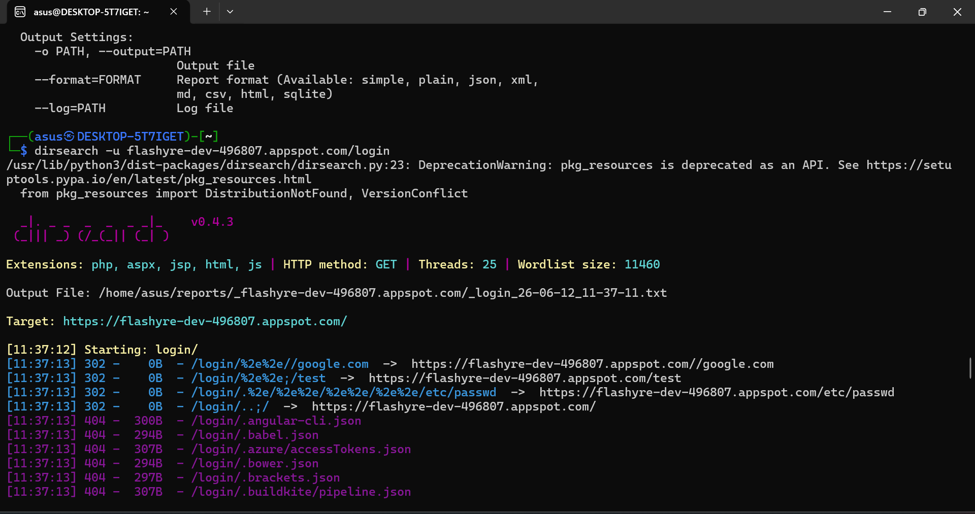

Tool Used
Dirsearch v0.4.3
Dirsearch is an automated web path scanning tool used to discover hidden files, directories, configuration files, and application resources that may not be directly accessible through normal website navigation.

Scan Configuration
The scan was executed using the HTTP GET method with the following settings:
- HTTP Method: GET
- Threads: 25
- Wordlist Size: 11,460 entries
- File Extensions Tested:
  - PHP
  - ASPX
  - JSP
  - HTML
  - JS
The scanner attempted to access commonly used configuration files, development files, backup files, and administrative resources.

Observations
During the assessment, multiple requests were sent to the target application to identify accessible resources.
Several path traversal and URL manipulation requests returned HTTP 302 redirect responses. The application redirected the requests to valid locations instead of exposing sensitive resources. This behavior indicates that the application correctly handled abnormal URL requests.
Examples observed during testing included:
- /login/..
- /login/%2e%2e//google.com
- /login/.%2e/%2e%2e/%2e%2e/etc/passwd
These requests were redirected by the server and did not expose any sensitive information.
Additionally, several configuration and development-related files were tested, including:
- .angular-cli.json
- .babel.json
- .azure-accessTokens.json
- .bower.json
- .buildkite/pipeline.json
All tested files returned HTTP 404 (Not Found) responses, indicating that the resources were not publicly accessible.

Security Analysis
The assessment identified that the application properly handled invalid requests and did not expose sensitive files or internal configuration data.
Key observations include:
- No source code exposure detected.
- No configuration files were publicly accessible.
- No credentials or authentication tokens were exposed.
- No evidence of path traversal vulnerabilities was observed.
- No backup files or development artifacts were accessible.
- Proper HTTP response codes were returned by the application.
The application's response behavior indicates appropriate handling of unauthorized resource requests.

DNS Enumeration and Domain Information Analysis
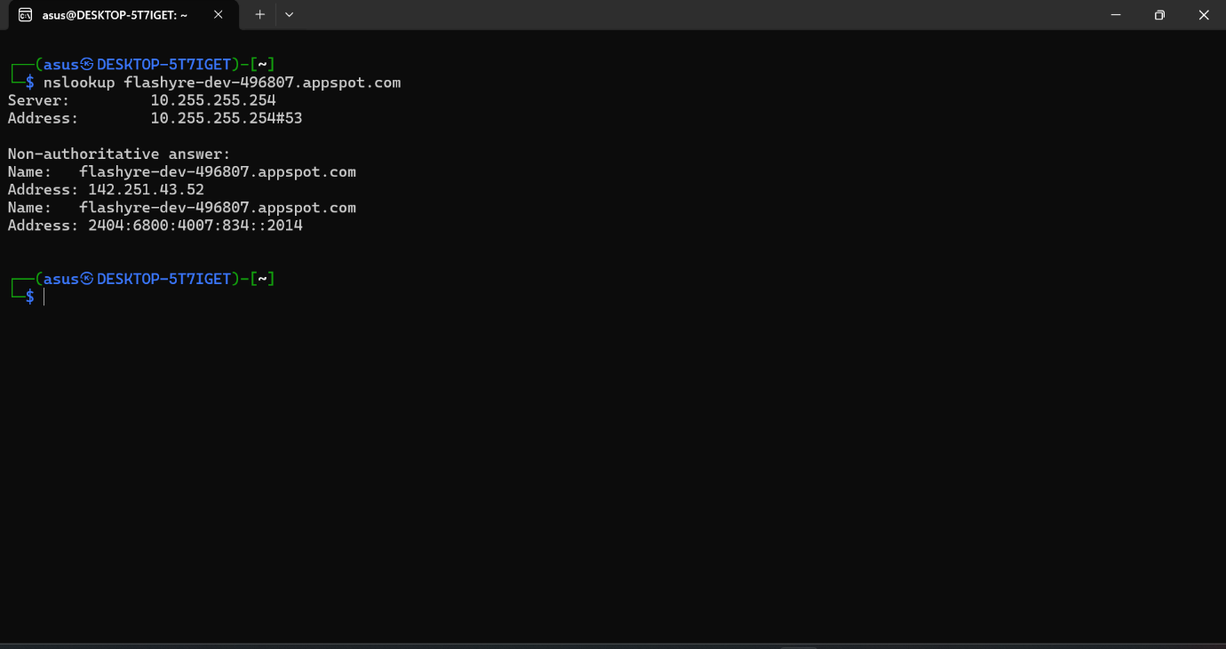
Objective
The objective of this assessment was to perform DNS enumeration on the target application domain in order to identify its IP address, DNS resolution details, hosting environment, and network-related information.

Tool Used
nslookup
Nslookup is a network administration utility used to query the Domain Name System (DNS) and obtain information about domain names, IP addresses, and DNS records.

Target Domain
flashyre-dev-496807.appspot.com

Command Executed
nslookup flashyre-dev-496807.appspot.com

Results Obtained
DNS Server Information
The DNS query was processed through the following DNS resolver:
- DNS Server IP Address: 10.255.255.254
- DNS Service Port: 53
This server was responsible for resolving the target domain name into its associated IP addresses.

IPv4 Resolution
The domain successfully resolved to the following IPv4 address:
142.251.43.52
This indicates that the target application is publicly reachable through this IPv4 address.

IPv6 Resolution
The domain also resolved to the following IPv6 address:
2404:6800:4007:834::2014
This confirms that the application supports IPv6 connectivity in addition to IPv4.

Hosting Environment Analysis
The target domain uses the following format:
flashyre-dev-496807.appspot.com
The presence of the appspot.com domain indicates that the application is hosted on Google App Engine, which is a cloud computing platform provided by Google Cloud Platform (GCP).
Google App Engine is a Platform-as-a-Service (PaaS) environment that allows developers to deploy and manage web applications without maintaining underlying server infrastructure.

Security Observations
During DNS enumeration, the following observations were made:
- The domain successfully resolved to valid public IP addresses.
- Both IPv4 and IPv6 records were present.
- No DNS misconfigurations were identified from the obtained results.
- No sensitive information was exposed through DNS resolution.
- The hosting provider was identified as Google Cloud Platform.
- DNS resolution completed successfully without errors.
Network Connectivity Verification and Ping Analysis
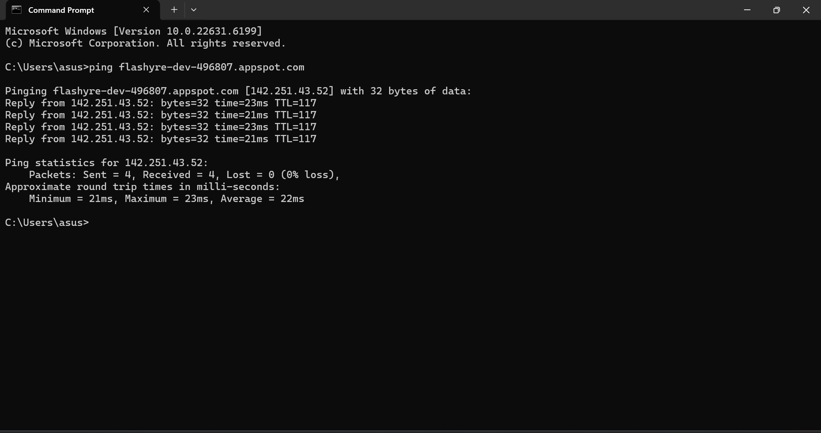

Objective
The objective of this test was to verify network connectivity, determine the reachability of the target host, and measure the response time between the testing system and the target application.

Tool Used
Ping Utility (ICMP Echo Request)
The ping command is a network diagnostic tool used to test communication between a local system and a remote host. It measures packet transmission success and response times.

Target Domain
flashyre-dev-496807.appspot.com

Command Executed
ping flashyre-dev-496807.appspot.com

Results Obtained
The target domain successfully resolved to the following IPv4 address:
142.251.43.52
The system transmitted four ICMP echo requests to the target server and received successful responses for all requests.
Response Details
Reply Number | Response Time
Reply 1 | 23 ms
Reply 2 | 21 ms
Reply 3 | 23 ms
Reply 4 | 21 ms
TTL Value Observed:
TTL = 117

Ping Statistics
The following statistics were observed during testing:
- Packets Sent: 4
- Packets Received: 4
- Packets Lost: 0
- Packet Loss Percentage: 0%
Round Trip Time (RTT):
- Minimum Time: 21 ms
- Maximum Time: 23 ms
- Average Time: 22 ms
Port Scanning and Service Enumeration
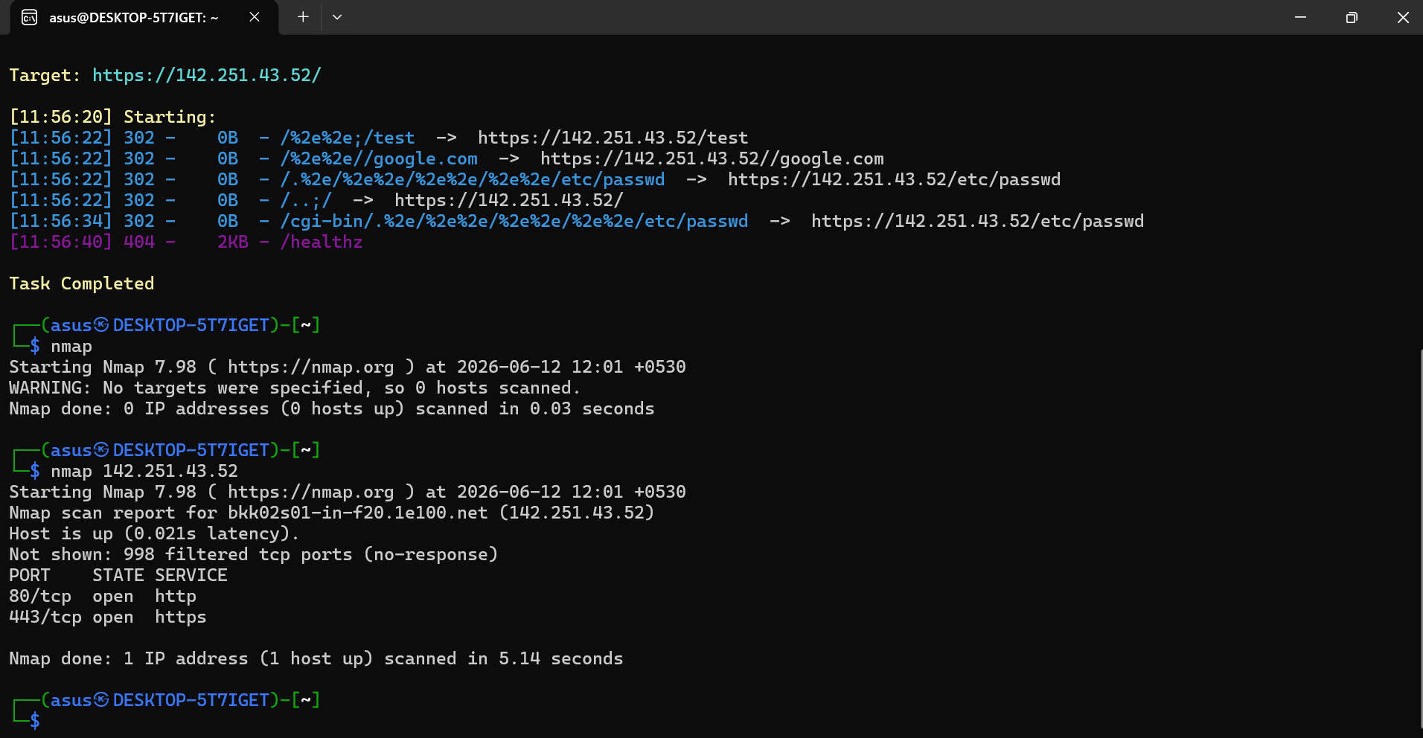

Objective
The objective of this assessment was to identify open network ports, discover running services, and evaluate the network exposure of the target application infrastructure.

Tool Used
Nmap (Network Mapper)
Nmap is an open-source network scanning tool used to discover hosts, identify open ports, detect running services, and perform network reconnaissance.

Target Host
IP Address:
142.251.43.52
Resolved Domain:
flashyre-dev-496807.appspot.com

Command Executed
nmap 142.251.43.52

Scan Results
The target host was successfully identified as online and responding to network requests.
Host Status
Host is up (0.021s latency)
This confirms that the target server was active and reachable during the assessment.

Open Ports Identified
Port | Protocol | State | Service
80 | TCP | Open | HTTP
443 | TCP | Open | HTTPS

Filtered Ports
Nmap reported:
Not shown: 998 filtered tcp ports (no-response)
This indicates that the majority of scanned ports did not respond to connection attempts and were protected by firewall rules or network filtering mechanisms.

Service Analysis
Port 80 (HTTP)
Port 80 was identified as open and running the HTTP service.
Purpose:
- Supports standard web traffic.
- Handles unencrypted HTTP requests.
- Commonly redirects users to HTTPS for secure communication.

Port 443 (HTTPS)
Port 443 was identified as open and running the HTTPS service.
Purpose:
- Supports encrypted web communications.
- Protects data confidentiality and integrity.
- Provides secure access to web applications.
The presence of HTTPS indicates that the target application supports encrypted communication between clients and the server.

Security Observations
During the scan, the following observations were made:
- The target host was reachable.
- Only essential web service ports were exposed.
- No unnecessary services were detected.
- Most ports were filtered by security controls.
- Network exposure was limited to standard web traffic.
- No unexpected open ports were identified.

